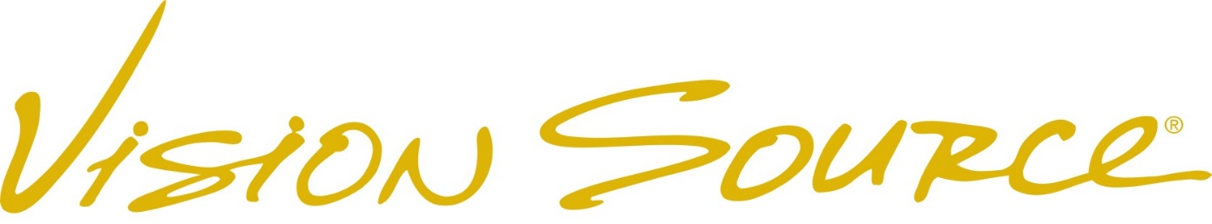

Media Contact: FOR IMMEDIATE RELEASE

Heather Suggitt

218-318-7857

hsuggitt@visionsource.com

www.visionsource.com

**MORE INNOVATION BY VISION SOURCE**

***Vision Source******announces Advisory Board, Roles Emerging from Healthcare Delivery System Wins by Local Leadership***

**KINGWOOD, Texas (June 26, 2014)** – Texas-based optometric alliance Vision Source has named seven leading optometrists to sit on a newly formed ‘Vision Source Administrator Advisory Board.’ The Vision Source Administrator organization is comprised of 170 local leaders and represents a unique component of the Company’s value proposition.

Vision Source President and CEO, Jim Greenwood commented, “At Vision Source, it is our mission to enrich lives by enabling independent optometrists to reach their full potential. One of the key factors in the success of Vision Source members is the leadership provided by the Administrators who serve at the local level. The healthcare delivery systems of the future are currently being designed and built in local markets, and as such Vision Source members are beginning to realize new opportunities for growth due to the abilities and actions of our Administrators.”

Greenwood added, “The Administrator group is comprised of independent optometrists who possess a broad range of experiences and a deep industry knowledge to share with the membership. From this illustrious group, we have carefully selected seven respected clinicians who will become an important part of the Company’s leadership infrastructure. They will impact decisions on policy and will be a continual source of guidance to our executive team. I want to congratulate the following individuals who have accepted the invitation to serve independent optometry in this manner: Dr. Dori Carlson of Grafton, North Dakota, Dr. Mario Gutierrez of San Antonio, Dr. Brett Hagen from Spokane, Washington, Texas, Dr. April Jasper of West Palm Beach, Florida, Dr. Pete Kehoe of Galesburg, Illinois, Dr. Amir Khoshnevis of Charlotte, North Carolina and Dr. Bill Strickland of Oxford, Mississippi.”

**About Vision Source**

Founded in 1991, Vision Source is North America’s largest network of independent optometrists consisting of 3,600+ key, eye care industry influencers. The clinicians in the Vision Source network enjoy a wide range of innovative technologies, practice management tools, marketing, and unsurpassed purchasing power. Leveraging these tools, the clinicians offer comprehensive eye examinations to their patients delivering an industry leading patient experience. For more information, call 888-558-2020 or visit www.visionsource.com.

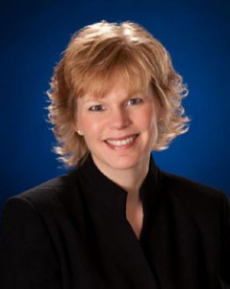

**Dori Carlson O.D., FAAO of Heartland Eye Car, Grafton. ND**

Dr. Carlson is a 1989 graduate of Pacific University College of Optometry in Forest Grove, OR. In 1990, she opened Heartland Eye Care. Dr. Carlson is active in the North Dakota Optometric Association (having served as the first female President in 1998), the American Optometric Association and the American Public Health Association. She is also a Fellow of the American Academy of Optometry.

In 2004 Dr. Carlson was elected to the American Optometric Association Board of Trustees. In June of 2010 she was elected to the position of President Elect and became the Association’s first female President in June 2011. In 1995 Dr. Carlson was honored as the North Dakota Young Optometrist of the Year and Optometrist of the Year in 2003. She and her husband/partner, Dr. Mark Helgeson, were recognized as the 2001 Walsh County Entrepreneurs of the Year.

**Dr. Mario Gutierrez, O.D. of Vision Source Alamo Heights, San Antonio, TX**

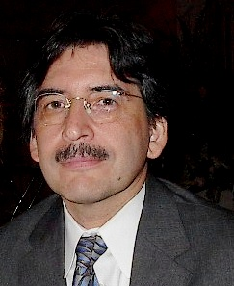Dr. Gutierrez received his Bachelor of Science degree in 1981 and his Doctor of Optometry in 1984 from the University of Houston. With 30 years of optometry experience, Dr. Gutierrez was one of the first Vision Source offices in the country and is now the administrator for 21 San Antonio Vision Source offices.

His Honors include: TLC Laser Center Advisory Board Chairman, Administrator of The Vision Source San Antonio, Chairman of the Independent Eyecare Providers of Texas, Director/CEO of Marrand Productions, Inc., President of VS Specialty Labs, LP. General Manager of VS Specialty, LLC., Co-Chair of Texas Optometric Association Third Party Committee, Vice President of N2 Eyes, LLC, Board member of Essentia Pharma, LLC, and he is the principle and founder of 2MEye, LLC Consulting. Dr. Gutierrez is a member of the American Optometric Association, Texas Optometric Association, American Academy of Optometry and Bexar County Optometric Society. He has been a Fellow of the prestigious American Academy of Optometry since 1992. His lectures include: Optometric CE on Cataract Surgery Co-management, Contact Lens Society of Texas on Orthokeratology, Optical Labs Manufacturers Association on Anti-reflective coating, lectures on Corneal Refractive Therapy, and has participated in many continuing education board discussions. He has also been published numerous articles in Review of Optometry and other eye care publications.

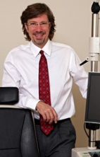**Dr. Brett Hagen, O.D. of Garland Family Vision in Spokane, WA**

Dr. Hagen received his Doctor of Optometry in 1991 from Pacific University College of Optometry in Forest Grove, Oregon. He is a member of both the American Optometric Association and the Optometric Physicians of Washington. In 1998-1999, he served as President of the Inland Society of Optometric Physicians of Washington and was the proud recipient of the “Washington Young Optometrist of the Year” in 1999. Dr. Hagen serves as President of the board of The Spokane Guild’s School and Neuromuscular Center. He was named their “Outstanding person of the Year” in 2005. He is also the administrator for Eastern Washington/North Idaho Vision Source area and is active in many other local charitable organizations.

Dr. Hagen’s professional interests include primary eye care, contact lenses, ocular disease and refractive surgery co-management. His passion, compassionate nature, and dedication to his profession enable him to provide his patients with thorough and comprehensive eye health care.



**April Jasper, O.D., FAAO of Advanced Eyecare Specialists, West Palm Beach, FL**

Dr. April Jasper graduated from Nova Southeastern University’s College of Optometry with highest honors in 1995. She grew up in West Palm Beach where she and her husband, David, currently raise two children. April graduated with highest honors in her class of 79 students as a Doctor of Optometry (O.D.). She completed a residency program in Boston, during which she received specialized training in primary care, contact lenses, and ocular disease. While a resident in Boston, Dr. Jasper held a position as an adjunct professor at NEWENCO University where she taught primary care and ocular disease to optometry students and ophthalmology residents.

Prior to moving to West Palm Beach in April 2002, Dr. Jasper practiced optometry in the Tallahassee, FL area and was President of the Northwest Florida Optometric Association for two years.

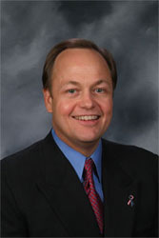

**Pete Kehoe O.D. of Kehoe Eye Care, PC of Galesburg and Gala, IL**

Dr. Kehoe has been practicing optometry since 1984. He is a graduate of the Illinois College of Optometry and Indiana University, and is a fellow of the American Academy of Optometry. Dr. Kehoe’s father founded Kehoe Optical, and in 1984 the practice of Marshall Marvelli, O.D. was purchased and merged with Kehoe Optical to become the present Kehoe Eye Care. As an optometrist, Dr. Kehoe has special interest in children’s vision, contact lenses, glaucoma and allergy/dry eyes. Dr. Kehoe has been active in the community as a past-president of the Lions Club and former member of the Chamber of Commerce board. He served as President of the American Optometric Association from 2008-2009 and was instrumental in the development of the InfantSEE® program. He is an active member of the American Optometric Association, the Illinois Optometric Association, and the West Central Illinois Optometric Society. In 2001 he was named Optometrist of The Year by the Illinois Optometric Association.

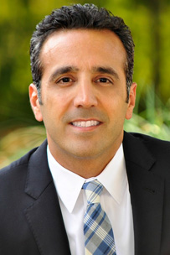**Amir Khoshnevis O.D. of Vision Studio 20/20, Charlotte, NC**

Dr. Khoshnevis is a graduate of Pennsylvania College of Optometry Bachelor of Sciences in Biology and University of North Carolina at Chapel Hill. In 2011, he was honored with two awards: the 2011 Philanthropist of the Year for Optometry Giving Sight and the Optometric Business Innovator of the Year by Vision Monday/Review of Optometry Business “Doc Stars in Practice Management.”

In addition to serving as a Vision Source Optometry Administrator, Dr. Khoshnevis is currently active in a wide variety of business, medical organizations and community organizations. He is a national committee member for Optometry Giving Sight, a professional development consultant and lecturer for Alcon, a faculty member for First Practice Academy, an advisory panel member for United HealthCare/OptumHealth, a presenter for AOA, SECO, and OptoWest, and an advisory panel member for a SynergEyes.

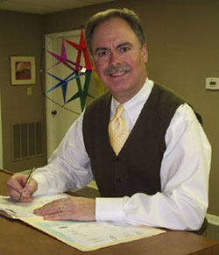**William Strickland O.D. of Oxford Eye Clinic, Oxford, MS**

Dr. William Strickland is a 1985 graduate of the University of Houston, College of Optometry, Houston, TX and then in 1994 degreed as Therapeutic Certified Optometrist.

With almost 30 years of optometric experience, he many honors including being voted the 2009 and 2009 Best Optometrist/Ophthalmologist in Oxford by the Oxford Eagle and the Vision Source Administrator of the Year 2012. His memberships include: American Optometric Association, Mississippi Optometric Association, American Public Health Association, and American Optometric Association Section on Cornea and Contact Lenses. Additionally, Dr. Strickland has been an active member of the Mississippi Optometric Association for 23 years and has served in many leadership capacities including president in 2001-2002.

###